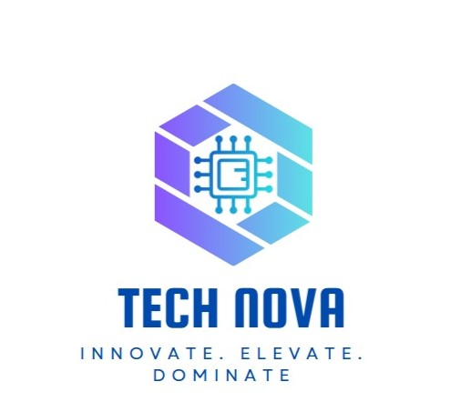

# Employee Engagement Template

# Employee Information

What is your job role?

Individual Contributor

Team Lead

Manager

Senior Manager

Regional Manager

Vice President

Management / C-Level

Partner

Owner

Volunteer

Intern

Other

What department do you work in?

Finance

IT

Human Resources

Operations

Testing

CRM

ERD

Customer Service

Did you feel a sense of belonging within the team and organization?

No. There is a strong feeling of exclusion and racism in the team. The environment doesn’t promote inclusivity or open communication.

How would you rate the work environment and culture?

Poor. The team lacks mutual respect and does not support diverse opinions.

How would you describe the effectiveness of your immediate supervisor?

Ineffective. The manager oppresses team members, limits their roles, and discourages idea sharing.

Were your goals and expectations aligned with the organization’s vision?

Yes, but the work environment hinders implementation and expression of ideas.

Did you find the company’s policies and procedures fair and equitable?

No. The promotion policy is unclear and discriminatory in some departments, favoring one gender.

How would you rate the organization’s support for maintaining a healthy work-life balance?

Very poor. The workload is heavy with no flexible arrangements or support.

Were you satisfied with your salary and benefits package?

No. There’s a large gap between our salary and the market rate. No health insurance or adequate incentives.

Did you receive enough training and development opportunities?

No. The company does not invest in developing employee skills or providing training.

Did you experience burnout or excessive stress in your role?

Yes. Due to manager oppression, unfair treatment, and lack of support.

Would you recommend this company as a good place to work?

No. The environment is toxic, and employees feel unheard.

Do you find your daily tasks engaging and meaningful?

No. The tasks do not contribute to personal or professional growth.

Do you feel recognized for your contributions and efforts?

No. Appreciation and acknowledgment are missing, especially when goals are met.

Do you feel challenged in your role in a positive way?

No. The manager limits development and does not encourage initiative.

How would you rate the overall work environment in the IT department?

How comfortable do you feel reaching out for help when facing technical challenges?

Not comfortable. The environment is **restrictive**, and the **manager’s oppressive behavior discourages open communication**. Employees fear being judged or dismissed when asking for help, which creates a barrier to collaboration and problem-solving

Have you received sufficient training and development opportunities in the last year?

No. The company has **not provided any structured training or development plans.** There is a clear neglect of employee skill enhancement, and no effort has been made to identify or support the growth needs of the finance team.

How would you describe your current workload?

The workload is unbalanced and overwhelming. Tasks are often assigned without proper structure or support, and there’s little consideration for work-life balance. Employees are expected to deliver high results without the necessary tools or recognition, leading to stress and burnout.

What improvements would you suggest to enhance employee engagement and job satisfaction?

1-Align salaries with market standards.

2-Create a fair promotion policy.

3- Offer training and incentives.

4- Train managers in leadership.

5- Ensure diversity and inclusion.

6- Implement hybrid work options.

Is leadership invested in and contributing to your culture initiatives?

No, leadership is disconnected from employees and not involved in improving culture.

•

Do you see yourself working here in a year?

No. Due to lack of growth, unfair treatment, and poor management.

Does your work challenge you and aid your development?

No. The tasks are repetitive and development is blocked by management.

•

Do you have the tools needed to maximize your potential here?

No. The current system is outdated and lacks necessary resources.

What motivates you to do your best work here?

The desire to grow, but the environment makes it hard.

What could we do better to support your career growth and development?

Provide fair promotions, training, and listen to employee ideas.